Help Support North Star Elementary PTA’s
Want to help us duct tape Dr. J to the wall???
Here are the details:  When: February 27, 2020@ 7 pm-PTA meeting  Where: North Star Cafeteria  How: Students wishing to participate can bring in a donation of $2 for two feet of tape by February 20th!! If your family is unable to attend the meeting, the tape you purchase will still be used to duct tape Dr. J to the wall!! Pictures will be posted on Facebook for all to see!! | 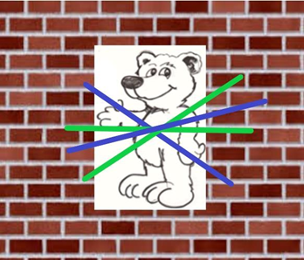

*All proceeds raised will go to help our sister school, Warner Elementary PTA whose PTA just started-Feel free to send in additional donations!
Please complete the form below and return by February 20th if your child would like to participate!
--------------------------------------------------------------------------------------------

Student(s) Name:__________________________________________________________________________________

# of pieces of tape:_______________________________ Total $ enclosed:____________________

