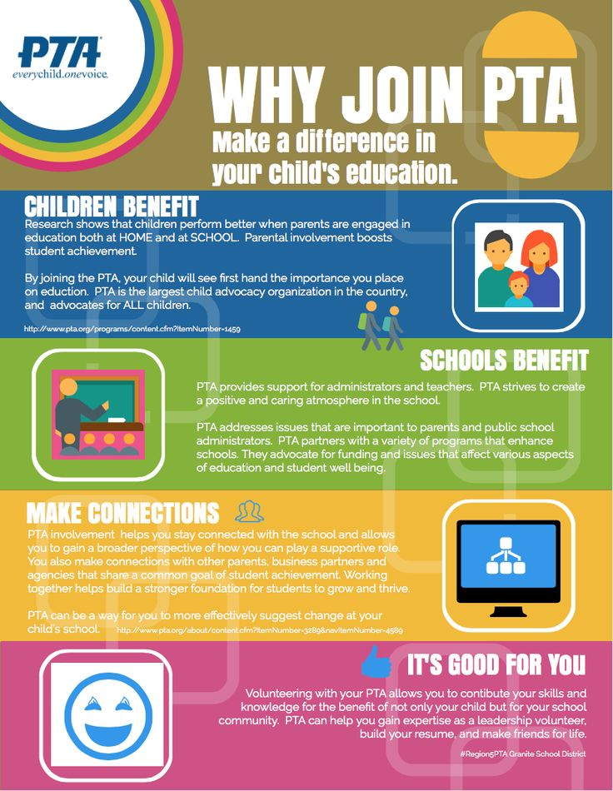
PTA MEMBERSHIP/STAFF APPRECIATION PAYMENT FORM
Each year the PTA raises money for a variety of school activities, teacher grants for items used in the classroom, and pays for programs the kids of North Star enjoy (Ashland field trips, 5th grade end of the year trips, ARC program, etc.). This year we will be looking for some more creative ways to provide for our students. Your membership to the PTA does not mean you have to volunteer, it just gives the North Star PTA additional funds to provide more activities and programs to your children.
______ I / we would like to become a 2020-2021 North Star PTA member

Membership: (Circle one) Individual $10 Two-Member $15

Two-Green-Member $25 Two-Blue-Member $50

I am also enclosing an additional $________ to go towards PTA Staff Appreciation Events.
We have many staff appreciation events planned this year and any support is appreciated – thank you.

Please pay by cash or check made payable to North Star PTA. You can also pay online via Cheddar Up at www.nspta.com. If paying online you do not need to complete the paper form. Paying online would be the easiest due to the school year starting remotely, but if you would like to pay by cash or check, you can mail your payment to the school (Attn: PTA): 1340 Little Baltimore Road, Hockessin, DE 19707.

Member Contact #1

First and Last Name: ___________________________Email: ___________________________
Male / Female (Circle one) *
Member Contact #2
First and Last Name: ______________________________Email: ___________________________
Male / Female (Circle one) *Email #2 must different than Email #1
Address_______________________________ City___________________ Zip _____________
Home Phone Number_____________________
Student’s Name________________________ Grade_______ Homeroom ___________
Student’s Name________________________ Grade_______ Homeroom ___________
Student’s Name________________________ Grade_______ Homeroom ___________
Student’s Name________________________ Grade_______ Homeroom__________
Please complete student names, grades and homeroom.
Please mark ALL that apply:
_____ Include the above contact information in the North Star PTA Family Directory.
_____ Include our family in the directory, but only list the following contact information (circle all that apply):
Address Phone Email Address #1 Email Address #2
_____ I would like to receive the PTA’s weekly eNews.
*: Information requested by Delaware State PTA.
For PTA office use only:
Amt Rec’d $__________ Cash________ Check #_________
As we explained, becoming a member of the North Star PTA, does not mean you have to volunteer, but we wanted to make you aware of the countless opportunities there are throughout the 2020-2021 school year, if you choose to volunteer. If every parent volunteered at least once during the school year, we would have every event covered and could possibly have even more events for the children of North Star. Please consider volunteering once this school year. Once we know when volunteers are allowed in the building, sign up genius’ will be posted on our website.
I am interested in learning more about the following activities and events. I understand that the committee chair will contact me with more information and I can then decide whether I want to help. Name _______________________
Child(ren)’s name ______________________________________________
Phone Number _______________________
Email ________________________
Description – some may be virtual or replaced with other ideas that can be done with social distancing
____ Picture Day – help the kids of North Star look their best for their picture
____ Walk-a-thon (in place of our Spirit Fest) – our 2nd biggest fundraiser of the year; assist students in moving to the correct areas
____ Pumpkin Patch – help with the parking lot traffic and making sure everyone is set up
____ Fall Family Fun Dance – help with food and light sticks
____ Winter Book Fair – help the kids of North Star pick out books to purchase
____ Main Event Night – help sell spirit wear
____ Bingo Night – help sell bingo boards, sell food, and spirit wear
____ Basket Preview Week – help the kids of North Star purchase tickets and chose baskets to place raffle tickets in
____ Carnival – our biggest fundraiser of the year; help run a game, monitor baskets, monitor silent auctions, etc.
____ Kindergarten Registration – help greet parents as they come to register their children for Kindergarten at North Star, sell spirit wear
____ Lip Sync – assist with making sure the kids who are performing are seated and ready when it is their turn to perform
____ Spring Book Fair – help the kids of North Star pick out books to purchase
____ Field Day – help run a game

